Hey, Lauren here! This is a free AI tool bundle I put together trained on 10+ years of growing audiences and converting sales from social media. It’ll give you what you need to:

- Generate revenue from your audience from written content
- Duplicate your voice so content sounds like you and gets reach
- Leverage DMs/social media messages to convert sales

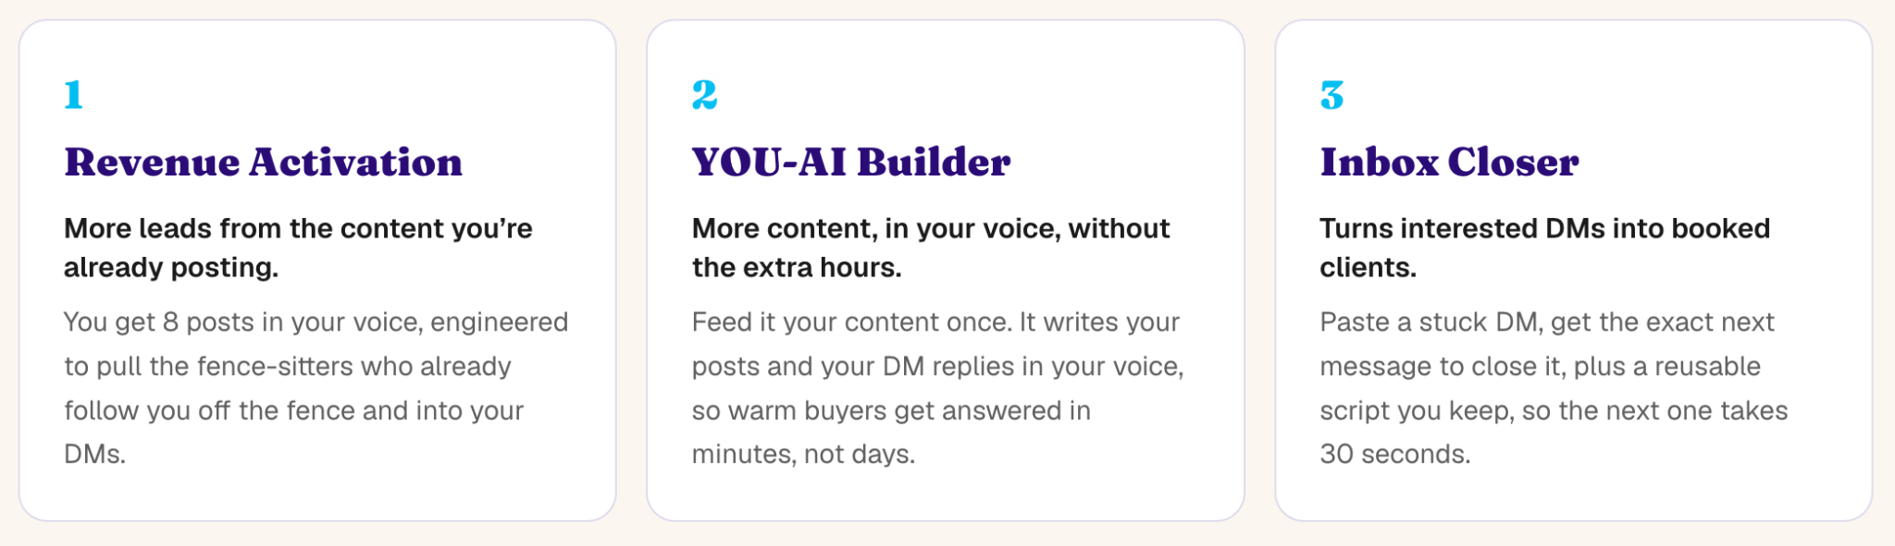

Click here for free access.

I’ve not yet launched it to the public, so because you’re here in Montenegro I’d be grateful if you shoot me any feedback once you’ve been able to use it.

Let’s connect on social media:
- LinkedIn
- Instagram
- Facebook
- YouTube

